**CS 207: Applied Database Practicum**

**In-Class Activity 2: Introduction to JavaScript and PHP, 13th August, 2018**

In this activity, you will have to create a Password validation form similar to the one attached below.

1. Please create a webpage which takes as input your name and password. (Use <form> tag to create the Password validation form)

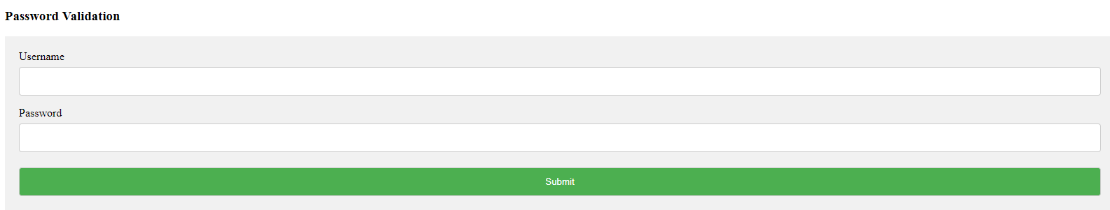

2. The password should contain a lowercase character, an uppercase character, a number and its length should be greater than 8.

Use JavaScript and DOM object to make the message box (use <div>) appear and disappear (e.g document.getElementById)

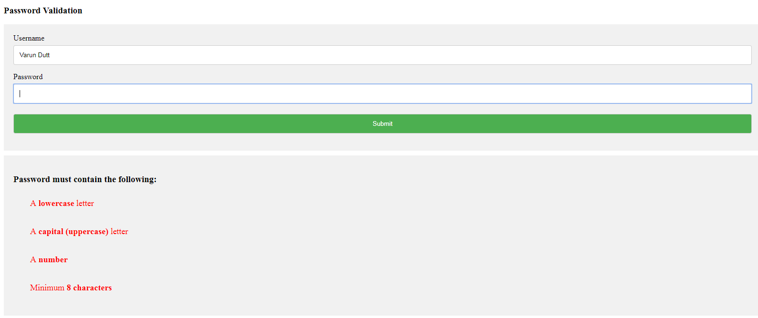

3. Validate that the password contain a lowercase character, an uppercase character, a number and its length should be greater than 8.

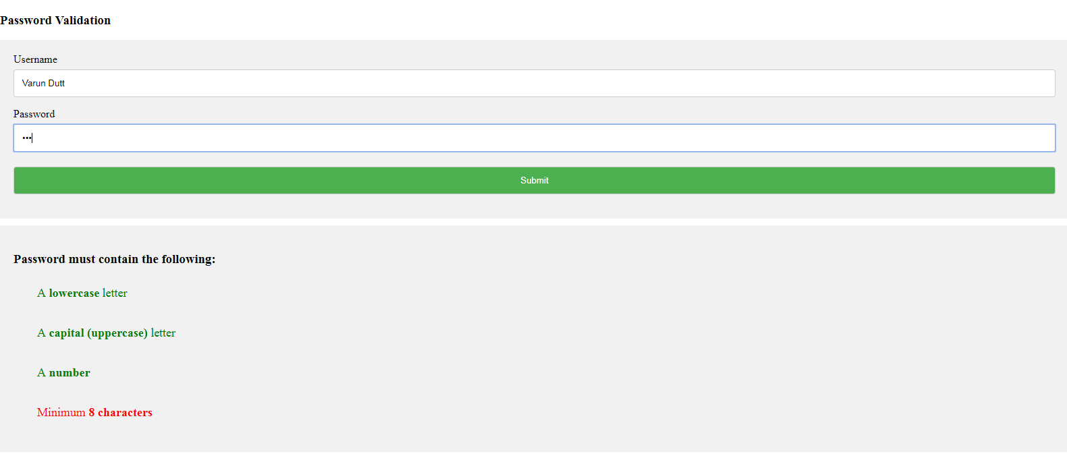

As can be seen from the image above the password length is not 8 characters so the message box is showing “Minimum 8 characters” as red while the others are green.

Use the class-list property to add and remove the color of the text.

To check if password contains lowercase character, uppercase and numbers use the following:

var lowerCaseLetters = /[a-z]/g;

var upperCaseLetters = /[A-Z]/g;

var numbers = /[0-9]/g;

3. **Bonus:** ONLY if you have done the above steps, then you can try this bonus for an extra point.

Using the POST/GET method display the username and password in another webpage.

